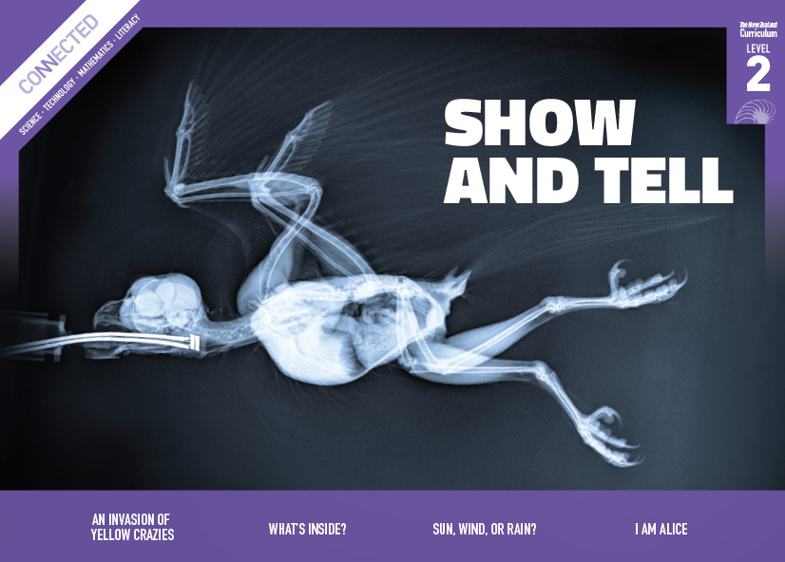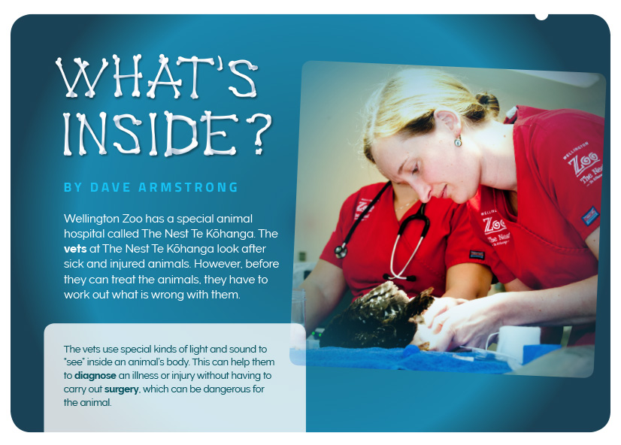
Connected
Level 2
2016

What’s Inside?
by Dave Armstrong

Overview
This article describes how vets at Wellington Zoo see inside sick and injured animals to diagnose what’s wrong with them. They use a range of technologies that harness specific kinds of light and sound. These same technologies are used to diagnose illness or injury in humans.
A Google Slides version of this article is available at www.connected.tki.org.nz – this text also has additional digital content, which is available online at www.connected.tki.org.nz.

Curriculum contexts

SCIENCE: Nature of Science: Communicating in science  Level 2 – Build their language and develop their understandings of the many ways the natural world can be represented. | Key Nature of Science ideas  Doctors and vets:  - gather and use evidence to make decisions about treatment  - develop medicines and other treatments through careful investigation, data gathering, and analysis  - interpret images produced from light or sound of different wavelengths to find out what is wrong with our bodies.
SCIENCE: Physical World: Physical inquiry and physics concepts  Level 2 – Explore everyday examples of physical phenomena, such as … light, sound, and waves. | Key science ideas  - Light can be absorbed, reflected, or transmitted through substances.  - There are different types (wavelengths) of light.  - Different types (wavelengths) of light can pass through or be absorbed or reflected by different substances.  - Sound vibrations can travel through different substances and be reflected off surfaces.
ENGLISH: Reading  Level 2 – Ideas: Students will show some understanding of ideas within, across, and beyond texts. | Indicators  - Uses their personal experience and world and literacy knowledge to make meaning form texts.  - Makes meaning of increasingly complex texts by identifying main ideas.  - Makes and supports inferences from texts with some independence.

The New Zealand Curriculum

Science capability: interpret representations

Capability overview
Scientists represent their ideas in a variety of ways. They might use models, graphs, charts, diagrams, photographs, and written text. A model is a representation of an idea, an object, a process, or a system. Scientists often use models when something is not directly observable. Models enable scientists to work on their ideas, even though they are often using a limited representation of the “thing” itself. It is important students can identify what is the same and what is different about the model and the thing. | It is important for students to think about how data is presented and ask questions such as:  - What does this representation tell us?  - What is left out?  - How does this representation get the message across?  - Why is it presented in this particular way?  This sort of questioning provides a foundation to critically interact with ideas about science in the media and to participate as critical, informed, and responsible citizens in a society in which science plays a significant role.

More about the capability

The capability in action
The science capability “Interpret representations” is about students understanding information that is presented as a description or in visual form and recognising the best way to present information.  Scientific representations include diagrams, models, charts, and graphs, as well as written text.  Scientists develop models and diagrams that best represent their theories and explanations.  Scientists  Scientists use:  - representations that can help both the original scientist and others clarify, critique, and evaluate their ideas, research, and theories  - computer and other kinds of modelling to predict what might happen in certain conditions and then test these predictions to see how accurate the model or idea is  - diagrams or models to communicate science ideas  - graphs to present data  - scientific forms of text involving argumentation that use evidence to debate explanations.  Students  Students should have opportunities to:  - learn to interpret a variety of representations, including models, diagrams, graphs, and text  - develop their own representations of scientific ideas, for example, through modelling using concrete materials or using their own bodies in mime and drama  - recognise how the representation matches the idea and how it is different  - consider and critique a range of representations, including scientific texts, newspaper articles about scientific matters, online information about science matters, and scientific representations developed by their peers. | Teachers  Teachers can:  - help students to be more critical consumers of science information by being explicitly critical themselves and modelling useful questions  - support students to evaluate how information is presented, for example, to assess if a graphical presentation has been done appropriately or is misleading  - ask questions such as:  - What do you think this representation tells us?  - What do the (arrows, lines, symbols, etc.) mean? (that is, helping your students interpret the features)  - Is anything left out? Do you think anything is missing from the representation?  - How does this get the message across?  - Is there anything more you need to know to be able to interpret this representation?  - How does the representation make the science idea clear?  - Which aspects of this representation could mislead the reader?  - Why is it presented in this way?  - Could you suggest a better way to represent it?  - establish a science classroom culture by:  - modelling and encouraging a critical stance  - encouraging students to consider the quality and interpretation of scientific representations  - having learning conversations that involve interpreting, critiquing, and developing representations to demonstrate the idea’s relevance in everyday life.

More activities to develop the capability

Meeting the literacy challenges

The literacy demands of this text require the students to understand and interpret factual descriptions of how vets diagnose and treat sick animals. Much of the technical information is included in explanations of ultrasounds, X-rays, and CAT scans. These explanations are accompanied by diagrams and photos that students will need to interpret to build their understanding.  The article contains subject-specific vocabulary relating to the technology the vets use, as well as biological vocabulary relating to animal bodies. Students can use a glossary for vocabulary that is not supported contextually. | The following strategies will support students to understand, respond to, and think critically about the information and ideas in the text.  The concepts relating to ultrasounds and CAT scans may be challenging for some students, who may benefit from having the text read to them.  You may wish to use shared or guided reading, or a mixture of both, depending on the reading expertise of your students and the background knowledge they bring to the text.  After reading the text, support students to explore the activities outlined in the following pages.

INSTRUCTIONAL STRATEGIES

Finding the main ideas  Have the students read the title and the text on page 10. PROMPT them to make connections with their prior knowledge by asking them to share what they know about vets and caring for sick animals.  Have the students look at examples of ultrasound images, X-rays, or CAT scans. They can look at the images in the article, but they could also look at images from the Internet, or they could even share examples of their own. DISCUSS what the images show and how they might have been generated.  - How do you think vets can see inside animal’s bodies? What do you think these pictures have in common?  - What can you see in this image? What part of the body does it show? What do you think might have gone wrong? How can you tell?  Have the students read pages 12–14 to check whether their ideas were correct. Clarify that the different kinds of images all rely on passing sound or light waves through the patient’s body.  Have the students skim the headings to IDENTIFY the three types of technologies vets use to see inside their patients. Create a table where students can RECORD the type of technology, the type of sound or light wave it uses, how it works, and what it is used for. Use the example of the ultrasound machine to MODEL how they can use a graphic organiser to capture the main ideas about a topic. If students struggle with this activity, provide more support through a shared activity.  Type of machine Type of sound or light wave How it works What it is used for  Ultrasound machine Ultrasound waves The sound waves bounce off the soft tissue, creating reflections that the machine turns into images. Often used for checking how babies are growing and for finding tumours.  X-rays  CAT scans | Draw the students’ attention to the final paragraph on page 16. ASK QUESTIONS to help them notice how the author reiterates the “big idea” on page 10 about the use of light and sound waves to “see” inside an animal’s body. PROMPT them to reflect on how well the author has communicated his message.  - What is the author’s main point here?  - Where did he make a similar point?  - What idea has he added to this point? (That the same technology is used with humans.)  - What is the author’s purpose?  - Why do you suppose the author told the story of Charlie, the sick cheetah?  - Thinking about the photographs and diagrams, as well as the words, how well do you think the author achieved his purpose? Why do you think that?  Dealing with unfamiliar vocabulary  EXPLAIN to the students that many of the words may be unfamiliar. Ask them to think, pair, and share the variety of ways the words are explained:  - in the glossary  - in the text  - in the captions  - in the photographs  - in the break-out text  - through repetition so that the reader gradually becomes familiar with the word and builds up a deeper understanding of what it means.  Have the students REVIEW the text to identify the topic words or phrases that describe what vets at Wellington zoo do (for example, “treat”, “diagnose”, “carry out surgery”). Have them record these words and their definitions in their science notebooks or on a class word wall, using the structure set out in the table below. Have the students evaluate each other’s definitions and example sentences and suggest improvements.  Word Meaning Example sentences

Meeting the literacy challenges

Extending the ideas
Allow the students to use some of the new words by undertaking a hot-seating activity. Some students could take on the role of the vets who looked after Charlie, the cheetah, and other students could take on the role of journalists who are writing an article about it for a local newspaper. The students could go on to write an article that explains what happened. Use this as an opportunity to DISCUSS the importance to scientists of communicating scientific information in a way that is accurate and interesting.
Note: Before undertaking this activity, the students could view Zoo Tales – A Tour of Auckland Zoo’s Vet Centre to get a better sense of the sort of work a zoo vet does.

Reading standard: by the end of year 4
The Literacy Learning Progressions
Effective Literacy Practice: years 1–4

TEACHER SUPPORT
Doctors and vets gather and use evidence to make decisions about treatment.  Doctors and vets interpret images produced from light or sound of different wavelengths to find out what is wrong with our bodies.  Light can be absorbed, reflected, or transmitted through substances. | 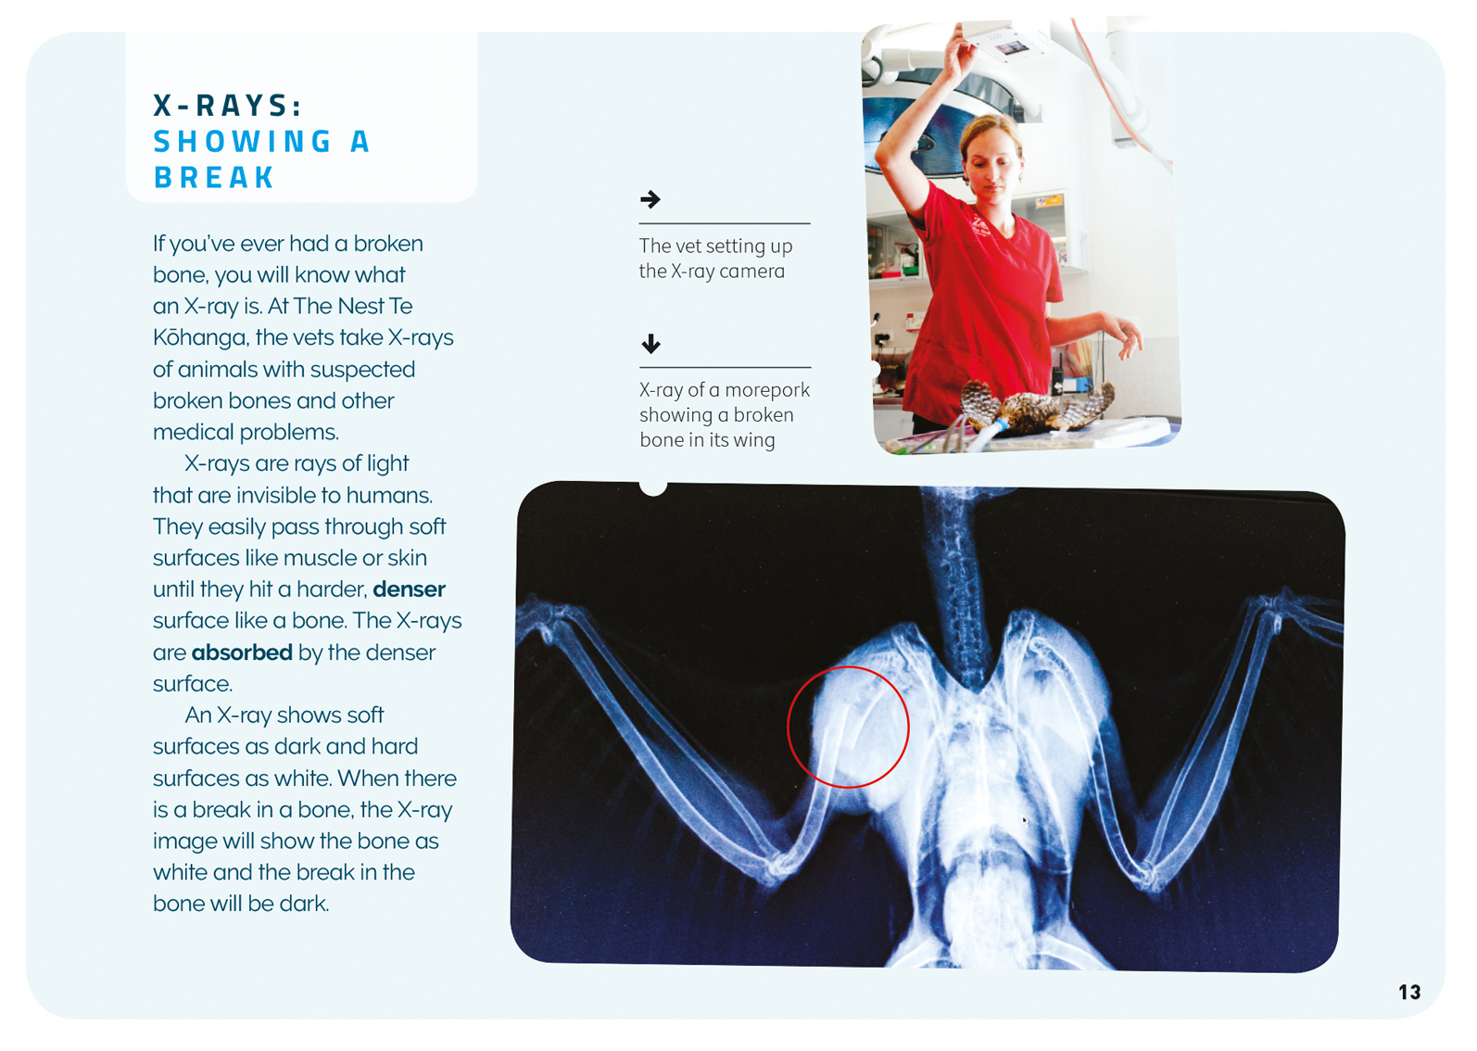

Learning activities – Exploring the science
The following activities are a guide for supporting students to explore and develop understandings about the science capability “Interpret representations”. Some activities focus directly on the science capability. Other activities extend student content knowledge across the learning areas. Adapt these activities to support your students’ learning needs.

Activity 1 – Exploring sound waves
Explore the concepts that sound is created by vibrations and that these vibrations can travel through different mediums. Begin by asking the students whether they think sound would travel faster through a solid, liquid, or gas.
The students can now explore this concept by recording their observations when they test what happens to sound when it is passed through a range of different media.
Test | Sound observations
Light taps heard through air (gas)
The tests could include the following.
- Working in pairs, one student taps on the desk and the second student records what they hear. They then repeat this, but this time, the second student puts their ear on the desk.
- The activity is repeated, this time with loud tapping. (See PBS Learning Media: Sound Vibrations.)
- The students make string phones, where the string and cup act as solids to help conduct the vibrations. (See the instructions for the String Phone Project.)
- The students put their ear to a metal pipe (such as one holding up a fence) and someone bangs on it from a long way away.
- Listening to sounds through a balloon filled with air and another filled with water.
- The students attach two pieces of string to a metal coat hanger and hold the other ends of the string in their ears with their fingers. They let the hanger bang against different objects.
- The students experiment with what happens when they tap glasses holding different amounts of water. (See Making Music with Water.)
- The students explore other ways sound vibrations are manipulated to make music. (See Building Science Concepts, Book 18.)
Discuss what the students have learned about how different materials affect the movement of sound waves. Have them sketch a diagram to explain this. Before they draw their diagrams discuss what makes a diagram effective (for example, labelling, simplicity, and accuracy). Draw up a set of criteria that they can then use to evaluate each other’s diagrams. They can then assess each other’s diagrams and decide which best communicates their findings.

Extending the learning
Explore the material in the resource links below on how ultrasound machines work. This is quite advanced, so it would be best to view and discuss this as a class or in groups. Ask the students to use what they learnt from the article, their experiments, and this additional information to create a simple explanation for a younger person who is going to have an ultrasound done and is feeling a bit nervous. They need to think about how to convey this scientific information in a way that is accurate and helpful. They could test their explanations by sharing them with younger students and having them repeat back what they understood.

Activity 2: Exploring light waves
Take the students outside and have them create silhouettes by using chalk to draw around each other’s shadows. Explain that an X-ray is like a shadow of our bones. The rays of light can go through all the soft parts of our body, but the bones stop them passing through completely, and they create a shadow image. (For further information, see Building Science Concepts, Books 9 and 10.)
With this big idea understood, the students could move to the Science Learning Hub activity on the Discovery and development of X-rays. This jigsaw activity provides the opportunity for students to research X-rays. It also provides links to additional resources.
Another group of students could investigate CAT scans.

Extending the learning
As with Activity 1, the students could create a reassuring and informative explanation for a younger child on what is involved in getting an X-ray or CAT scan. Students could present this information in the form of a pamphlet or a video.

Learning activities – Exploring the science

RESOURCE LINKS

Building Science Concepts  Book 18 – Exploring Sound Using Sound-makers and Musical Instruments  Book 9 – Shadows: Effects of the Absence of Light  Book 10: Light and Colour: Our Vision of the World  Connected  “Saffron’s Skeleton”, Connected 2, 2011 and TSM  Science Learning Hub  http://link.sciencelearn.org.nz/resources/985-x-ray-imaging  http://link.sciencelearn.org.nz/resources/1744-see-through-body-introduction  http://link.sciencelearn.org.nz/resources/1028-discovery-and-development-of-x-rays  Other sources  Sketchfab: 3-D models of skeletons: https://sketchfab.com/jjaakkgg/collections/skeletons  Vets and zoos  Auckland Zoo – Our animals (a file of animal images and information): www.aucklandzoo.co.nz/sites/explore-the-zoo/Mammals/list  Auckland Zoo Vet Centre – New Zealand Centre for Conservation Medicine (with video): www.aucklandzoo.co.nz/sites/explore-the-zoo/zoo-precincts/NZCCM  Zoo Tales – Giraffe Zabulu’s hoof x-ray (Auckland Zoo): www.aucklandzoo.co.nz/sites/news/media-releases/Zoo-Tales-Giraffe-Zabulus-hoof-x-ray  Charlie the orangutan’s check-up (Auckland Zoo): www.aucklandzoo.co.nz/sites/news/media-releases/Zoo-Tales-Charlies-check-up  Wellington Zoo – Our animals (a file of animal images and information): https://wellingtonzoo.com/our-animals/  The Nest Te Kōhanga: https://wellingtonzoo.com/conservation/saving-wildlife-in-the-nest-te-kohanga/  Animal care at Wellington Zoo: https://wellingtonzoo.com/our-animals/animal-care/  Hamilton Zoo – Our animals (a file of animal images and information): http://hamiltonzoo.co.nz/our-animals/  Experiments with sound  String phone project: www.sciencekids.co.nz/projects/stringphone.html  Making music with water: www.sciencekids.co.nz/experiments/makemusic.html | PBS Learning Media: Sound vibrations: www.pbslearningmedia.org/resource/phy03.sci.phys.howmove.lp_sound/sound-vibrations/  Ultrasound information  Information on ultrasound: www.webmd.com/a-to-z-guides/what-is-an-ultrasound  General information and PowerPoint for teachers: www.radiologyinfo.org/en/info.cfm?pg=genus  Teacher background information: www.nibib.nih.gov/science-education/science-topics/ultrasound  Video – how ultrasound works: www.youtube.com/watch?v=I1Bdp2tMFsY  Animated explanation of how an ultrasound machine works: www.youtube.com/watch?v=-eEA-2hNoqU (The video promotes a website with more information.)  How does an ultrasound machine work? www.ultrasoundtechniciancenter.org/ultrasound-knowledge/how-ultrasound-machines-work.html  X-ray information  Video – How X-rays work: www.youtube.com/watch?v=hTz_rGP4v9Y  Video – Explaining X-rays to children: http://kidshealth.org/en/kids/video-xray.html  Video – What are X-rays?: http://mocomi.com/x-rays/  CAT scan information  Student-friendly video explaining a CT scan: http://kidshealth.org/en/kids/video-ctscan.html  How a Cat scan works: http://kidshealth.org/en/parents/ct-head.html  How a CAT scan works: https://www.youtube.com/watch?v=tqGmqRrxajQ

